UI state management

🗂️ What is UI State Management
# Source: AI Source: Provided by: [Data Path: Persons Table -> ID Column: 1, Name_En Column: Motasem Essam] -> From: [ChatGPT] on [1/23/2026]
UI State Management is the practice of organizing, storing, and updating the UI state of an application in a structured, predictable way. It ensures that the interface reacts correctly whenever data or user interactions change.
👉 Think of UI State Management as the traffic control system for your app’s UI: it keeps track of what’s happening, and makes sure the UI updates consistently.

🔑 Key Points
# Source: AI Source: Provided by: [Data Path: Persons Table -> ID Column: 1, Name_En Column: Motasem Essam] -> From: [ChatGPT] on [1/23/2026]
- Separates UI state from business logic.
- Ensures the UI is predictable and consistent.
- Can be local (per component) or global (shared across the app).
- Often works with ViewModel, Controllers, or state management libraries.

🧱 Examples of UI State Management

1️⃣ Local Component State
# Source: AI Source: Provided by: [Data Path: Persons Table -> ID Column: 1, Name_En Column: Motasem Essam] -> From: [ChatGPT] on [1/23/2026]
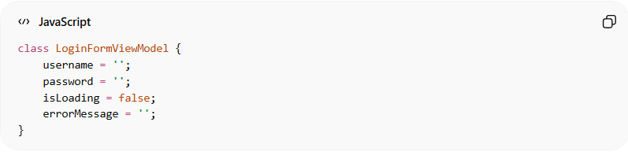
class LoginFormViewModel {
username = '';
password = '';
isLoading = false;
errorMessage = '';
}
- State is specific to the login form.
- Changes to isLoading or errorMessage update only this component.

2️⃣ Global Application State
# Source: AI Source: Provided by: [Data Path: Persons Table -> ID Column: 1, Name_En Column: Motasem Essam] -> From: [ChatGPT] on [1/23/2026]
- Used in larger apps where multiple components share the same state.
- Example libraries: Redux, MobX, Vuex
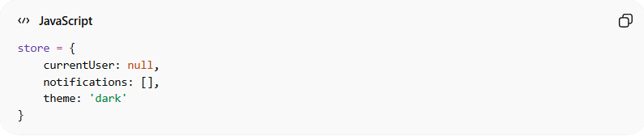
store = {
currentUser: null,
notifications: [],
theme: 'dark'
}
- Any part of the app can observe or update the shared state.

🔄 How It Works
# Source: AI Source: Provided by: [Data Path: Persons Table -> ID Column: 1, Name_En Column: Motasem Essam] -> From: [ChatGPT] on [1/23/2026]
- User interacts with the UI → triggers an action
- State manager updates the UI state → local or global
- UI reacts automatically → re-renders with the new state
- Business logic and data remain separate from UI state
Example: Clicking a “like” button → isLiked = true → button updates to “Liked” without touching backend logic

💡 Key Idea
# Source: AI Source: Provided by: [Data Path: Persons Table -> ID Column: 1, Name_En Column: Motasem Essam] -> From: [ChatGPT] on [1/23/2026]
UI State Management ensures that the interface is always in sync with the underlying state, making apps more predictable, testable, and maintainable.

📝 Summary
# Source: AI Source: Provided by: [Data Path: Persons Table -> ID Column: 1, Name_En Column: Motasem Essam] -> From: [ChatGPT] on [1/23/2026]
- Keeps UI state organized
- Makes UI reactive and predictable
- Can be local or global
- Works closely with ViewModel, Controllers, or state libraries
- Separates UI concerns from business logic

